St Gregory’s Catholic Primary School
‘Loving and Learning’
The St Gregory’s Curriculum
Science

Colossians 1: 15-17 The Son is the image of the invisible God, the firstborn over all creation. For in him all things were created: things in heaven and on earth, visible and invisible, whether thrones or powers or rulers or authorities; all things have been created through him and for him. He is before all things, and in him all things hold together.
Catholic Social Teaching (CST): Stewardship. Human Dignity.
Catholic School Pupil Profile: Curious. Grateful. Learned.
Curriculum Intent for Science
It is our intention to develop in our children, a lifelong curiosity and interest in the sciences. We intend for children to have the opportunity to learn through varied systematic investigations leading them to ask and answer scientific questions about the world around them. As children progress through the year groups, they build on their skill in working scientifically, as well as their scientific knowledge and understanding.

Curriculum Implementation for Science
At St Gregory’s science is taught thematically with each year group covering five themes during an academic year. Staff follow the STEM planning documents to provide children with the most creative, engaging and theoretical lessons every week. At St Gregory’s, teachers create a positive attitude to science learning within their classrooms and reinforce an expectation that all children are capable of achieving high standards in science.
The acquisition of key scientific knowledge is an integral part of our science lessons. The progression of skills for working scientifically are developed through the year groups and scientific enquiry skills are of key importance within lessons.
Children are encouraged to ask their own questions and be given opportunities to use their scientific skills and research to discover the answers. This curiosity is celebrated within the classroom. Planning involves teachers creating practical, engaging lessons with opportunities for precise questioning in class to test conceptual knowledge and skills, and assess children regularly to identify those children with gaps in learning.
Working Scientifically skills are embedded into lessons to ensure these skills are being developed throughout the children’s school career, and new vocabulary and challenging concepts are introduced through direct teaching. This is developed through the years, in keeping with the topics.
Teachers demonstrate how to use scientific equipment, and the various Working Scientifically skills in order to embed scientific understanding. Teachers find opportunities to develop children’s understanding of their surroundings by accessing outdoor learning. Through enrichment days, such as ‘science week’, we promote the profile of Science and allow time for the children to freely explore scientific topics.
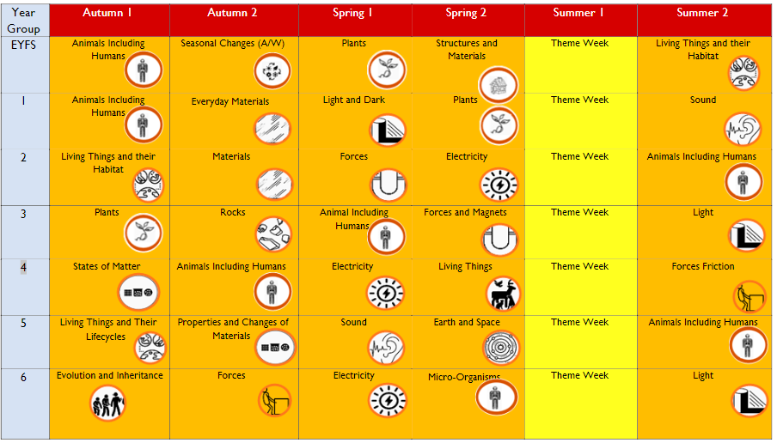

Curriculum Impact for Science

